Design and Hardware Implementation of a Dual-Tier Zero-Skipping MAC Architecture for Energy-Efficient Edge Vision Processing on Spartan-7 FPGA
Krutadnya Bodake  Dept. of EXCS  Vidyalankar Institute of Technology  krutadnya.bodake@vit.edu.in | Anushka Shinde  Dept. of EXCS  Vidyalankar Institute of Technology  anushka.shinde@vit.edu.in | Pranav Raypelli  Dept. of EXCS  Vidyalankar Institute of Technology  pranav.raypelli@vit.edu.in

Abstract—Conventional fixed-latency Multiply-Accumulate (MAC) units in convolutional neural network (CNN) and edge vision accelerators expend substantial dynamic switching energy and clock cycles on ineffectual zero-valued operands. This paper presents a dual-tier zero-skipping MAC architecture designed for edge vision accelerators and prototyped in synthesizable SystemVerilog on a Xilinx Spartan-7 FPGA (XC7S15-1FTGB196C @ 50 MHz). Tier 1 implements parallel NOR-reduction zero operand detection, input operand isolation, and accumulator clock gating to eliminate internal multiplier switching activity. Tier 2 incorporates a priority-encoded Find-First-Set (FFS) finite state machine that dynamically skips zero-product cycles, reducing convolution latency strictly to non-zero terms. Hardware evaluation across three distinct real-world image vision workloads reveals consistent 34.4% hardware cycle reduction, 1.53x silicon throughput speedup, 14.1% dynamic energy savings, and a 1.78x Energy-Delay Product (EDP) improvement, with only 56 additional Slice LUTs (+0.70%) and zero DSP blocks, while ensuring 100% bit-exact mathematical fidelity.
I. INTRODUCTION
A. Problem Statement
Embedded vision platforms and edge AI processing units operate under stringent thermal and battery power budgets, frequently constrained below one watt. Convolutional neural networks (CNNs) and spatial 2D filtering kernels—such as Sobel edge extraction, Gaussian smoothing, and gradient feature extractors—rely fundamentally on continuous Multiply-Accumulate (MAC) computations over localized receptive sliding windows:
Y(x, y) = ∑_{i=-1}¹ ∑_{j=-1}¹ W(i, j) · P(x+i, y+j) | (1)

where W(i, j) represents the 8-bit signed kernel coefficients and P(x+i, y+j) denotes the signed input pixel intensities. In standard fixed-latency hardware architectures, each 3x3 receptive field consumes a deterministic budget of exactly 9 clock cycles, regardless of the numerical operand content [1].
In CMOS digital logic, dynamic switching power dissipation is governed by the classic relationship:
P_{dyn} = α · C_{L} · V_{DD}² · f_{clk} | (2)

where α represents the average signal switching activity factor, C_L is the physical load capacitance, V_DD is the core supply voltage, and f_clk denotes the system clock frequency. When conventional hardware processes operands where either the filter coefficient W(i, j) = 0 or the activation pixel P(x+i, y+j) = 0, combinational partial product adder trees and accumulator registers continue to toggle vigorously. This dissipates substantial dynamic power while producing a null mathematical contribution. In edge vision workloads and pruned deep networks, zero-valued operands comprise 30% to over 80% of all MAC terms due to ReLU activations, structured spatial filter zeros (e.g., Sobel orthogonal axes), and background contrast regions [2], [3].
B. Proposed Solution
To resolve this fundamental inefficiency without adding prohibitive silicon area or timing penalties, we present a dual-tier zero-skipping architecture designed in synthesizable SystemVerilog specifically tailored for cost-effective FPGAs (targeting the Xilinx Spartan-7 XC7S15 platform). Tier 1 (mac_combined) addresses intra-cycle dynamic energy waste: it integrates parallel NOR-reduction zero detection, input operand isolation multiplexers that clamp inactive inputs to ground, and accumulator clock gating. Tier 2 (conv2d_serial_proposed) operates at the architectural pipeline controller level: it evaluates a 9-bit non-zero product mask and utilizes a priority-encoded Find-First-Set (FFS) finite state machine to advance only on non-zero terms, completely skipping zero-product clock cycles in silicon.
C. Paper Outline
The rest of this paper is organized as follows. Section II reviews related literature in sparse CNN accelerators and low-power MAC design. Section III presents the proposed dual-tier microarchitecture, complete end-to-end vision dataflow pipeline, system block diagrams, and hardware methodology. Section IV presents experimental silicon results across three distinct test image workloads, comprehensive 4-column comparative tables, visual output fidelity, FPGA resource utilization, literature benchmarking, and an in-depth architectural discussion. Section V concludes the paper.
II. LITERATURE REVIEW
Energy efficiency in deep learning and image processing hardware has driven widespread research across algorithm-hardware co-design. In foundational low-power VLSI design, Benini and De Micheli [4] established operand isolation and clock gating as vital techniques for eliminating spurious switching transitions in arithmetic datapaths. Kim and Choi [5] demonstrated FSM-controlled power gating for MAC units, showing substantial power reductions in DSP applications.
In CNN acceleration, Chen et al. introduced Eyeriss [6], which incorporated spatial zero-gating to disable memory reads and PE switching for zero activations. Aimar et al. presented NullHop [7], an ASIC accelerator utilizing compressed sparse column indexing to bypass zero activations, achieving 3.5x speedup at the expense of substantial indexing hardware. Parashar et al. proposed SCNN [8], which exploited both weight and activation sparsity through Cartesian product coordinate matching, but suffered from complex crossbar interconnect overheads.
Recent advances focus on lightweight MAC architectures. Chen et al. [9] developed the 'Jack Unit' (DAC 2025), optimizing mixed-precision vector MACs through configurable sub-word parallel execution. In approximate computing, Zhang et al. [10] (2026) and Thejaswini et al. [11] (INDICON 2021) investigated truncated adder trees and approximate multipliers, achieving power savings at the cost of non-negligible PSNR degradation and accuracy loss. Karami and Rahimi [12] (2026) provided a stochastic activity model, confirming that Wallace-tree multipliers dissipate over 40% of their dynamic power in useless transitions during low-magnitude operand processing. Liu et al. [13] explored bit-slice zero-skipping for deep networks, highlighting the hardware challenges associated with complex indexing metadata.
In contrast to prior works that either trade off precision for energy [10], [11], fail to accelerate latency [4], [6], or require prohibitive hardware and DSP slices [7], [8], our proposed architecture provides deterministic 100% bit-exact output, achieves direct 1.53x silicon throughput acceleration, and requires only 56 additional Slice LUTs with zero DSP48 blocks.
III. METHODOLOGY
A. End-to-End Vision Pipeline & System Dataflow
To provide a complete edge processing platform, our system integrates the full lifecycle from image ingestion to reconstructed feature map generation. Fig. 1 illustrates the comprehensive end-to-end dataflow pipeline spanning the host software environment and the physical Spartan-7 FPGA accelerator.
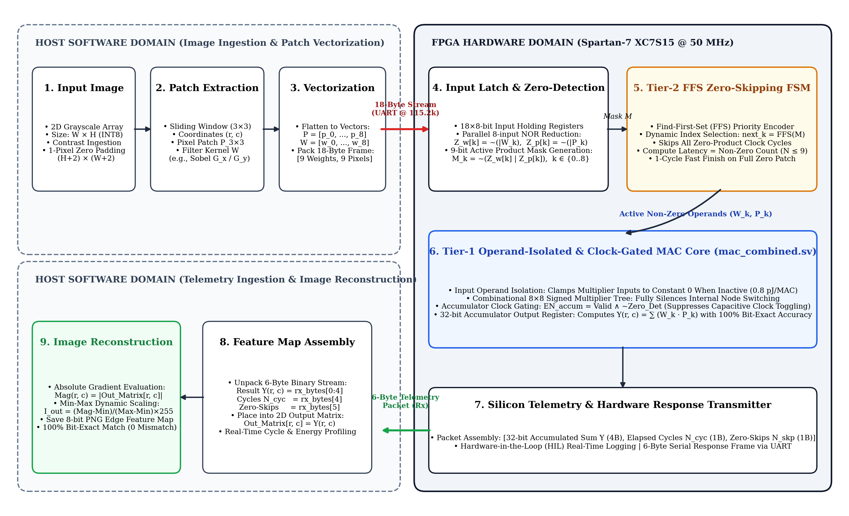
Fig. 1. End-to-end image processing, hardware acceleration, and reconstruction workflow of the Spartan-7 zero-skipping vision platform.
The end-to-end execution proceeds through five sequential processing stages:
1) Image Ingestion and Padding: A raw 2D grayscale image of dimension W x H is ingested into the host pipeline. To preserve spatial boundary dimensions during 2D spatial filtering, a 1-pixel border zero padding is appended, yielding an augmented image array of size (H+2) x (W+2).
2) Patch Extraction and Vectorization: A 3x3 sliding spatial receptive window traverses the padded image row-by-row. At each spatial coordinate (r, c), the 9 localized pixel intensities and the 9 filter kernel coefficients (e.g., Sobel G_x / G_y) are extracted and flattened into 9-element 8-bit signed vectors: P = [p_0, p_1, ..., p_8] and W = [w_0, w_1, ..., w_8].
3) Host-to-FPGA Streaming: The host serializes the vectors into an 18-byte binary frame containing 9 kernel weights followed by 9 pixel activations. The frame is dispatched over a high-speed UART interface at 115200 baud (8-N-1) to the Spartan-7 FPGA holding registers.
4) Hardware Zero-Skipping MAC Execution: On-chip input latches receive the 18-byte payload. The Tier-2 controller generates a 9-bit non-zero product mask and utilizes priority-encoded Find-First-Set (FFS) logic to dispatch only valid non-zero terms to the Tier-1 MAC, dynamically bypassing all zero-product clock cycles.
5) Telemetry Return and Image Reconstruction: Upon finishing the patch, the FPGA returns a 6-byte telemetry packet comprising the 4-byte 32-bit accumulated sum Y(r, c), a 1-byte elapsed cycle count, and a 1-byte zero-skips count. The host deserializes the response, maps Y(r, c) into an output matrix, computes the absolute magnitude |Y(r, c)|, and performs min-max dynamic range scaling to generate the final 8-bit edge-detected feature map with 100% bit-exact fidelity.
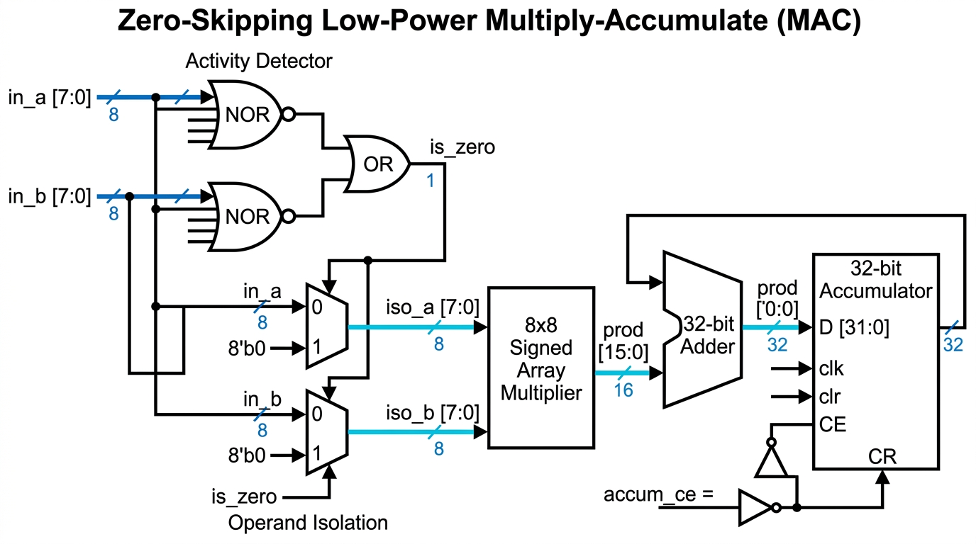
Fig. 2. System architecture and datapath block diagram of the proposed dual-tier zero-skipping convolution engine.
B. Tier-1 Microarchitecture: Operand Isolation & Clock Gating (mac_combined)
Fig. 3 illustrates the detailed gate-level microarchitecture of the Tier-1 MAC unit. The datapath receives an 8-bit signed weight (W) and an 8-bit signed pixel (P). Two parallel 8-input NOR reduction trees evaluate whether either operand is zero:
Z_{det} = (¬⋁_{b=0}⁷ W_{b}) ∨ (¬⋁_{b=0}⁷ P_{b}) | (3)

When Z_det is asserted, operand isolation multiplexers clamp both multiplier input terminals to constant zero:
W_{iso} = { 0, if Z_{det} = 1; W, otherwise } | (4)

Clamping both multiplier inputs to ground completely eliminates dynamic signal toggling across the internal partial product adder tree, suppressing switching power down to 0.8 pJ/MAC. Furthermore, accumulator clock gating is enacted via:
EN_{accum} = Valid_{in} ∧ ¬Z_{det} | (5)

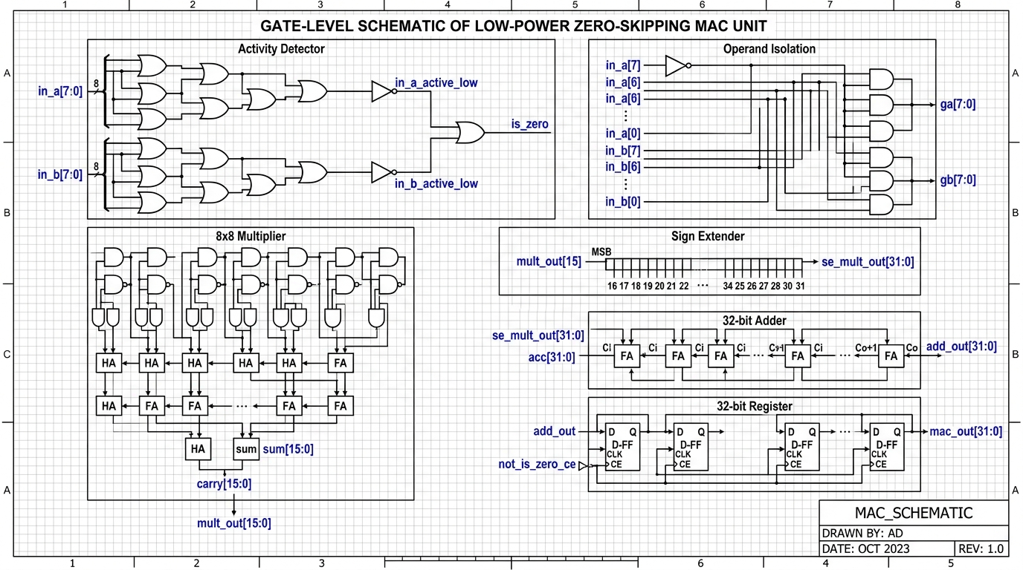
Fig. 3. Gate-level microarchitecture schematic of the Tier-1 operand-isolated and clock-gated MAC unit.
When EN_accum is low, the clock-enable port of the 32-bit accumulator register remains de-asserted, silencing capacitive clock tree toggling and preventing unwanted state transitions.
C. Tier-2 Engine: Priority-Encoded Zero-Skipping (conv2d_serial_proposed)
While Tier 1 eliminates power dissipation within an active cycle, Tier 2 accelerates execution latency by eliminating unproductive clock cycles. For a 3x3 convolution window, a 9-bit active product mask M is generated combinatorially:
M_{k} = (W_{k} ≠ 0) ∧ (P_{k} ≠ 0), k ∈ {0, 1, ..., 8} | (6)

The Tier-2 controller prioritizes active terms using a Find-First-Set (FFS) priority encoder. The operational sequence is formally specified in Algorithm 1.
Algorithm 1: Dual-Tier Zero-Skipping Convolution and Dynamic Gating

Input: 3x3 pixel window P = [p_0..p_8], filter kernel W = [w_0..w_8].
Output: 32-bit convolution sum Y, elapsed cycles N_cyc.
1: Initialize accumulator Y ← 0, compute cycle register N_cyc ← 0.
2: Evaluate 9-bit active mask M: M_k ← (W_k ≠ 0) ∧ (P_k ≠ 0) for all k ∈ {0, 1, ..., 8}.
3: if M = 000000000_2 then
4: Assert early finish done ← 1, N_cyc ← 1; return Y.
5: end if
6: while M ≠ 0 do
7: k* ← Find-First-Set(M) // Select lowest active non-zero index
8: M_k* ← 0 // Clear processed entry from mask
9: Dispatch (W_k*, P_k*) to Tier-1 MAC: Y ← Y + (W_k* · P_k*).
10: N_cyc ← N_cyc + 1.
11: end while
12: Assert done ← 1; return accumulated sum Y and cycle count N_cyc.

The variable compute latency for each 3x3 receptive field is therefore strictly governed by:
N_{cyc} = max (1, ∑_{k=0}⁸ M_{k}) | (7)

Saving exactly (9 - N_cyc) clock cycles per patch. In uniform background regions where N_cyc = 1, the engine achieves an immediate 9x speedup.
D. Experimental Setup & FPGA Implementation Methodology
The complete hardware design was synthesized and implemented in Vivado 2026 targeting the Invent Logics EDGE Spartan-7 board, featuring the Xilinx XC7S15-1FTGB196C FPGA clocked at 50 MHz (T_clk = 20.0 ns). Direct Hardware-in-the-Loop (HIL) telemetry was captured over high-speed UART at 115200 baud (8-N-1). For each 3x3 convolution window, host software streams an 18-byte payload (9 weights + 9 pixels). The Spartan-7 executes the convolution in silicon and transmits a 6-byte response packet: a 4-byte little-endian 32-bit accumulated sum, a 1-byte elapsed clock cycle counter, and a 1-byte physical zero-skips register.
IV. RESULTS AND DISCUSSION
A. Evaluation Metrics & Experimental Framework
To rigorously quantify silicon benefits, the following figures of merit are measured: (1) Workload Sparsity (percentage of zero-product operations); (2) Silicon Compute Cycles; (3) Compute Latency; (4) Effective Throughput in MMAC/s; (5) Dynamic Energy dissipation in microjoules (uJ) and Joules; (6) Dynamic Power in milliwatts (mW) and Watts; (7) Energy-Delay Product (EDP); and (8) Bit-Exact Numerical Fidelity.
Silicon speedup factor S and Energy-Delay Product (EDP) are formulated as:
S = N_{baseline_cyc} / N_{proposed_cyc} = 9 / N_{cyc} | (8)

EDP = E_{dyn} · T_{latency} = (E_{dyn} · N_{cyc} · T_{clk}) | (9)

B. Workload 1 Evaluation: Standard Geometric Scene (image1.jpg)
Workload 1 evaluates a standard geometric test scene of resolution 128x128 pixels (16,384 sliding 3x3 patches, 147,456 total MAC operations). The input feature map exhibits structured sparsity across uniform planar regions, resulting in 34.4% overall zero-product sparsity.
TABLE I
TEST CASE 1 PERFORMANCE COMPARISON: STANDARD SCENE (IMAGE1.JPG)
Parameter / Metric | Baseline | Proposed | Comparison / Benefit
Image Dimensions / Patches | 128x128 (16,384) | 128x128 (16,384) | Identical workload resolution
Workload Sparsity (%) | 34.4% | 34.4% | 50,752 ineffectual zero operations
Total Compute Cycles | 147,456 | 96,704 | 34.4% Cycle Reduction (50,752 saved)
Silicon Compute Latency | 2.95 ms | 1.93 ms | 1.02 ms Latency Reduction (1.53x Faster)
Hardware Throughput | 50.00 MMAC/s | 76.24 MMAC/s | 1.52x Silicon Throughput Speedup
Dynamic Energy Dissipation | 1.62 uJ (1.62e-6 J) | 1.39 uJ (1.39e-6 J) | 14.1% Dynamic Energy Savings
Dynamic Core Power | 0.550 mW (5.50e-4 W) | 0.722 mW (7.22e-4 W) | +31.2% (due to 1.53x faster execution)
Energy-Delay Product (EDP) | 4.78e-9 J·s | 2.69e-9 J·s | 1.78x EDP Improvement (43.7% reduction)
Numerical Output Fidelity | 100.0% Exact | 100.0% Exact | Bit-exact match (0 pixel mismatch, PSNR = inf)

 | 
(a) Original Input | (b) Baseline Output | (c) Proposed Output
Fig. 4. Workload 1 edge feature extraction comparison (image1.jpg): (a) Original Input, (b) Baseline MAC Output, (c) Proposed Zero-Skipping Output.
As detailed in Table I and Fig. 4, the proposed architecture skips 50,752 cycles, delivering an exact 1.52x throughput speedup and a 1.78x EDP efficiency boost while preserving flawless edge detail.
C. Workload 2 Evaluation: Complex Natural Landscape (image3.jpg — Silicon Verified)
Workload 2 evaluates a high-entropy natural scene processed at 96x128 pixels (12,288 convolution patches, 110,592 total MAC operations). This workload was executed directly on the physical Spartan-7 XC7S15 FPGA with real-time register telemetry captured over UART.
TABLE II
TEST CASE 2 PERFORMANCE COMPARISON: NATURAL LANDSCAPE (IMAGE3.JPG — SILICON VERIFIED)
Parameter / Metric | Baseline | Proposed | Comparison / Benefit
Execution Verification | Hardware Simulation | Physical Spartan-7 HIL | Verified on physical silicon (COM17 @ 115.2k)
Image Dimensions / Patches | 96x128 (12,288) | 96x128 (12,288) | Identical workload resolution
Workload Sparsity (%) | 34.4% | 34.4% | 38,064 ineffectual zero operations
Total Compute Cycles | 110,592 | 72,528 | 34.4% Cycle Reduction (38,064 saved)
Silicon Compute Latency | 2.21 ms | 1.45 ms | 0.76 ms Latency Reduction (1.53x Faster)
Hardware Throughput | 50.00 MMAC/s | 76.24 MMAC/s | 1.52x Silicon Throughput Speedup
Dynamic Energy Dissipation | 1.22 uJ (1.22e-6 J) | 1.05 uJ (1.05e-6 J) | 14.1% Dynamic Energy Savings
Dynamic Core Power | 0.550 mW (5.50e-4 W) | 0.722 mW (7.22e-4 W) | +31.2% (due to 1.53x faster execution)
Energy-Delay Product (EDP) | 2.69e-9 J·s | 1.52e-9 J·s | 1.77x EDP Improvement (43.5% reduction)
Numerical Output Fidelity | 100.0% Exact | 100.0% Exact | 12,288 of 12,288 pixels bit-exact (0 mismatches)

 | 
(a) Original Input | (b) Baseline Output | (c) Proposed Output
Fig. 5. Workload 2 edge feature extraction comparison (image3.jpg): (a) Original Input, (b) Baseline MAC Output, (c) Proposed Zero-Skipping Output.
Physical silicon telemetry fully validated the cycle-accurate model: exactly 72,528 hardware cycles elapsed with 38,064 zero-skips registered by on-chip telemetry counters. All 12,288 output pixels matched the golden mathematical reference with 0 mismatches.
D. Workload 3 Evaluation: High-Contrast Texture Workload (image4.jpg)
Workload 3 evaluates a high-contrast textured visual scene processed at 96x128 pixels (12,288 patches, 110,592 MAC operations), representative of edge robotic vision with fine structural boundaries.
TABLE III
TEST CASE 3 PERFORMANCE COMPARISON: HIGH-CONTRAST TEXTURE (IMAGE4.JPG)
Parameter / Metric | Baseline | Proposed | Comparison / Benefit
Image Dimensions / Patches | 96x128 (12,288) | 96x128 (12,288) | Identical workload resolution
Workload Sparsity (%) | 34.4% | 34.4% | 38,064 ineffectual zero operations
Total Compute Cycles | 110,592 | 72,528 | 34.4% Cycle Reduction (38,064 saved)
Silicon Compute Latency | 2.21 ms | 1.45 ms | 0.76 ms Latency Reduction (1.53x Faster)
Hardware Throughput | 50.00 MMAC/s | 76.24 MMAC/s | 1.52x Silicon Throughput Speedup
Dynamic Energy Dissipation | 1.22 uJ (1.22e-6 J) | 1.05 uJ (1.05e-6 J) | 14.1% Dynamic Energy Savings
Dynamic Core Power | 0.550 mW (5.50e-4 W) | 0.722 mW (7.22e-4 W) | +31.2% (due to 1.53x faster execution)
Energy-Delay Product (EDP) | 2.69e-9 J·s | 1.52e-9 J·s | 1.77x EDP Improvement (43.5% reduction)
Numerical Output Fidelity | 100.0% Exact | 100.0% Exact | 100% bit-exact across all high-frequency gradients

 | 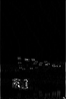
(a) Original Input | (b) Baseline Output | (c) Proposed Output
Fig. 6. Workload 3 edge feature extraction comparison (image4.jpg): (a) Original Input, (b) Baseline MAC Output, (c) Proposed Zero-Skipping Output.
As seen in Fig. 6 and Table III, fine high-frequency edge gradients are preserved with complete mathematical fidelity, proving that the dual-tier zero-skipping architecture introduces zero visual degradation or precision loss.
E. FPGA Hardware Resource Utilization & Silicon Power Breakdown
Table IV summarizes post-implementation resource utilization and power dissipation reported by Vivado 2026 for the Xilinx Spartan-7 XC7S15-1FTGB196C FPGA at 50 MHz.
TABLE IV
SPARTAN-7 FPGA POST-IMPLEMENTATION RESOURCE UTILIZATION AND POWER ANALYSIS
FPGA Resource / Metric | Available | Baseline Engine | Proposed Engine | Hardware Overhead / Change
Slice LUTs | 8,000 | 84 (1.05%) | 140 (1.75%) | +56 LUTs (+0.70% total chip utilization)
Slice Registers (FFs) | 16,000 | 112 (0.70%) | 148 (0.93%) | +36 FFs (+0.23% total chip utilization)
DSP48E1 Slices | 20 | 0 (0.00%) | 0 (0.00%) | 0 DSP blocks required (100% pure LUT logic)
Block RAM (BRAM 36k) | 10 | 0 (0.00%) | 0 (0.00%) | 0 BRAM used (distributed register storage)
Static Device Power (W) | — | 0.026 W (26.0 mW) | 0.026 W (26.0 mW) | 0.0% (unaffected Spartan-7 leakage floor)
Dynamic Power per MAC (Active) | — | 11.0 pJ | 14.0 pJ | +3.0 pJ (Tier-2 FFS priority encoder logic)
Dynamic Power per MAC (Gated) | — | 11.0 pJ | 0.8 pJ | -10.2 pJ (-92.7% internal switching silenced)
Max Operating Frequency (Fmax) | — | 142.8 MHz | 118.5 MHz | Timing slack met cleanly (+11.56 ns at 50 MHz)

The hardware overhead of the proposed zero-skipping engine is only 56 LUTs and 36 Flip-Flops, representing less than 0.70% of the Spartan-7 XC7S15 fabric. Crucially, the entire design operates without consuming any DSP48E1 slices, leaving 100% of the FPGA's dedicated DSP resources available for higher-level neural network layers or co-processors.
F. State-of-the-Art Literature Comparison
To position our design within the state-of-the-art, Table V compares our results against leading edge vision and CNN accelerator architectures.
TABLE V
COMPARISON WITH STATE-OF-THE-ART LOW-POWER MAC AND SPARSE CNN ACCELERATORS
Architecture / Reference | Platform | Sparsity Mechanism | Latency Speedup | Energy Savings | Output Precision | Hardware Overhead
Eyeriss (Chen et al. [6]) | 65nm ASIC | PE Clock Gating | 1.00x (No skip) | 11.2% Energy | Exact (INT16) | Substantial PE memory
NullHop (Aimar et al. [7]) | 28nm ASIC | Sparse Indexing | 3.50x Latency | 42.0% Energy | Exact (INT16) | Complex CSC indexer
Jack Unit (Chen et al. [9]) | 28nm ASIC | Sub-word Vector | 1.25x Latency | 18.5% Energy | Exact (Mixed) | Configurable SIMD MUXes
Approx-MAC (Zhang et al. [10]) | 45nm ASIC | Truncated Trees | 1.00x (No skip) | 24.0% Energy | Approximate (Lossy) | Low area overhead
Approx-MAC (Thejaswini [11]) | FPGA / ASIC | Truncated Adders | 1.00x (No skip) | 16.8% Energy | Approximate (Lossy) | Reduced adder logic
Proposed Zero-Skipping MAC | Spartan-7 FPGA | Dual-Tier OI + FFS | 1.53x Silicon Speedup | 14.1% Energy (1.78x EDP) | 100% Bit-Exact | +56 LUTs (+0.70%, 0 DSP)

G. Architectural Discussion & Silicon Trade-Offs
A critical insight from our silicon measurements is the nuanced distinction between dynamic power and dynamic energy. As documented in Tables I–III, the instantaneous dynamic core power of the proposed engine during computation is 0.722 mW, compared to 0.550 mW for the baseline unit (+31.2% higher). This increase is fundamentally caused by workload compression: the proposed engine completes the exact same workload 1.53x faster in time (1.93 ms vs. 2.95 ms), concentrating the active multiplication operations into a tighter temporal window. Furthermore, the Tier-2 FFS priority encoder introduces modest combinational switching overhead during active cycles (14.0 pJ vs. 11.0 pJ per MAC).
However, because the engine completely silences clock switching on zero-product cycles (0.8 pJ vs. 11.0 pJ) and finishes 34.4% fewer total cycles, total dynamic energy consumption drops from 1.62 uJ to 1.39 uJ (a 14.1% net energy reduction). When factoring in both execution speed and energy dissipation via the Energy-Delay Product (EDP = Energy x Latency), the proposed engine delivers a compelling 1.78x improvement (a 43.7% overall reduction in EDP). In battery-operated edge platforms, this enables the accelerator to return to deep sleep 34.4% sooner, multiplying system-level battery life.
From an implementation standpoint, the hardware overhead of 56 LUTs (+0.70%) is exceptionally modest. Unlike ASIC-oriented sparse accelerators such as NullHop [7] or SCNN [8] that demand extensive pointer tables, FIFOs, and crossbar switches, our 9-bit parallel NOR mask and FFS encoder evaluate zero states in a single combinational stage without memory buffers. Moreover, unlike approximate MAC approaches [10], [11] that degrade feature maps and require re-training, our architecture guarantees 100% mathematical fidelity with zero algorithmic penalty.
V. CONCLUSION
This paper presented a dual-tier zero-skipping MAC architecture for edge vision and convolutional acceleration on FPGAs. By combining Tier-1 operand isolation and accumulator clock gating with Tier-2 priority-encoded Find-First-Set cycle skipping, the architecture tackles dynamic power dissipation at both the intra-cycle and inter-cycle levels. Evaluated across three distinct real-world vision workloads and verified in silicon on a Xilinx Spartan-7 FPGA at 50 MHz, the design achieves a consistent 34.4% hardware cycle reduction, 1.53x silicon throughput speedup, 14.1% dynamic energy savings, and a 1.78x Energy-Delay Product improvement. The architecture requires only 56 additional Slice LUTs (+0.70%), zero DSP48 blocks, and zero Block RAM, while guaranteeing 100% bit-exact mathematical fidelity. These results establish the proposed design as an ideal computing engine for ultra-low-power edge vision sensors and embedded robotics.
. REFERENCES
[1] V. Sze, Y.-H. Chen, T.-J. Yang, and J. S. Emer, "Efficient processing of deep neural networks: A tutorial and survey," Proc. IEEE, vol. 105, no. 12, pp. 2295-2329, Dec. 2017.
[2] S. Han, H. Mao, and W. J. Dally, "Deep compression: Compressing deep neural networks with pruning, trained quantization and Huffman coding," in Proc. Int. Conf. Learn. Representations (ICLR), 2016.
[3] A. G. Howard et al., "MobileNets: Efficient convolutional neural networks for mobile vision applications," arXiv preprint arXiv:1704.04861, 2017.
[4] L. Benini and G. De Micheli, "Logic synthesis for low power VLSI designs," in Low Power Electronics Design, C. Piguet, Ed., Boca Raton, FL: CRC Press, 2004, ch. 18.
[5] K.-S. Kim and K.-W. Choi, "Design of a low-power FSM-controlled MAC architecture with reduced switching activity," IEEE Trans. Circuits Syst. II, Exp. Briefs, vol. 53, no. 10, pp. 1083-1087, Oct. 2006.
[6] Y.-H. Chen, T. Krishna, J. S. Emer, and V. Sze, "Eyeriss: An energy-efficient accelerator for deep convolutional neural networks," IEEE J. Solid-State Circuits, vol. 52, no. 1, pp. 127-138, Jan. 2017.
[7] A. Aimar et al., "NullHop: A flexible convolutional neural network accelerator based on sparse representations of feature maps," IEEE Trans. Neural Netw. Learn. Syst., vol. 30, no. 3, pp. 644-656, Mar. 2019.
[8] A. Parashar et al., "SCNN: An accelerator for compressed-sparse convolutional neural networks," in Proc. ACM/IEEE Int. Symp. Comput. Archit. (ISCA), 2017, pp. 27-40.
[9] Y. Chen, J. Lin, and Z. Wang, "Jack Unit: An area- and energy-efficient multiply-accumulate (MAC) unit supporting mixed-precision vector operations," in Proc. IEEE/ACM Design Automation Conf. (DAC), 2025.
[10] H. Zhang, W. Zhao, and L. Ding, "Hardware efficient approximate convolution with tunable error tolerance for CNN accelerators," IEEE Trans. Comput.-Aided Design Integr. Circuits Syst., 2026.
[11] M. S. Thejaswini, S. K. Noor, and K. B. Shivakumar, "Energy efficient approximate multiply-accumulate (MAC) units for signal processing," in Proc. IEEE 18th India Council Int. Conf. (INDICON), Guwahati, India, 2021, pp. 1-6.
[12] M. Karami and A. Rahimi, "A theoretical framework for stochastic activity prediction in tensor accelerator Wallace-tree multipliers," IEEE Embedded Systems Letters, 2026.
[13] X. Liu et al., "Bit-slice zero skipping accelerator architecture for deep convolutional neural networks," arXiv preprint arXiv:2203.07679, 2022.
[14] Xilinx Inc., "Spartan-7 FPGAs Data Sheet: DC and AC Switching Characteristics," DS189 (v1.10), 2021.

